Adoptions & Insight Portal (AIP) - Quick Reference Guide
- Log into AIP
  - User ID email address – xxxx.xxxxxxx@ucr.edu
  - Password P@ssword (you will need to change your password on initial login)

- Upon logging into AIP, the COURSE LIST page will display.
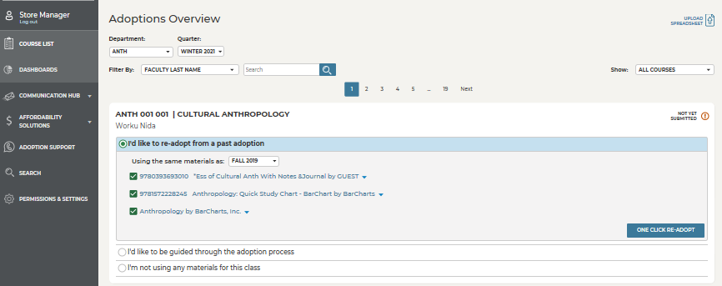
You may re-adopt from a past term by clicking this dial

Click ALL DEPARTMENTS drop menu to select the appropriate course

You may choose to be guided through the process
- Will need book ISBN or Author/Title
- Or view detailed adoption history
Select this dial, in the event no adoption is needed, materials will be supplied by instructor or an OER title is adopted.
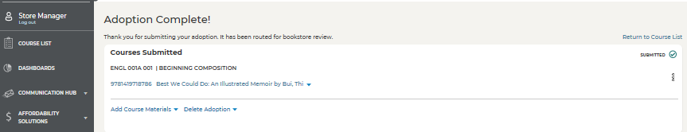
Once the adoption has been placed it can always be revisited

